OLED Display
The OLED is a device that provides a 128x 32 pixel black and white organic light emitting diode display. Its useful for displaying all manner of data in text form, as well as simple shapes and images. It allows us to get feedback from a device that is not connected to a computer.
Wiring
Start by wiring the device over the I2C bus as shown in the diagram below. Do not remove the 9DoF board from the previous activity.
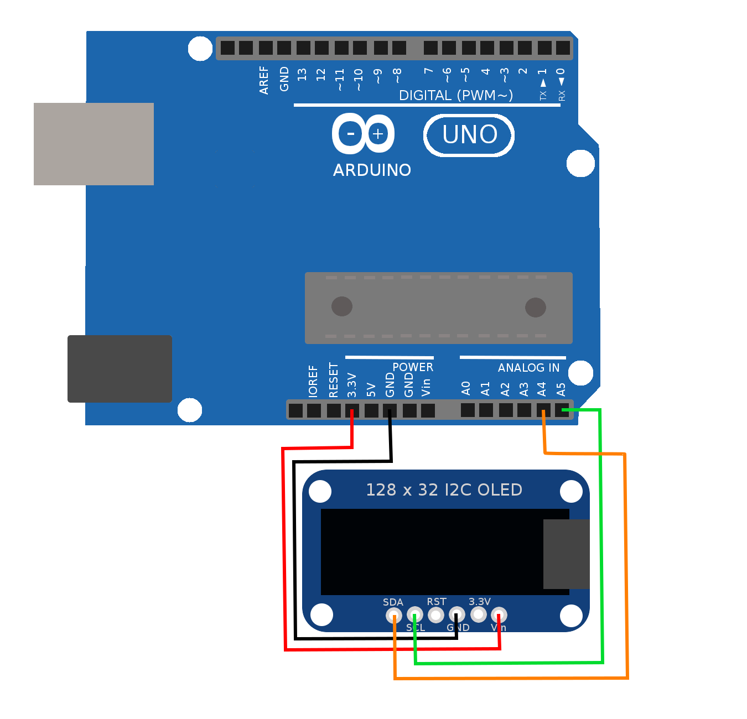
 | Device Pin | Arduino Pin | Name
 | Vin | 3.3V | Power
 | GND | GND | Ground
 | SCL | A5 | Serial Clock
 | SDA | A4 | Serial Data

Testing
Open the included sketch called 'OLED'. Upload that sketch to the Arduino, but do not expect any feedback over the serial monitor for this sketch. The program should display to the OLED screen, and not the serial monitor. You should first see the Adafruit splash screen displayed for a moment, and then the screen should start to count how long the program has been running.
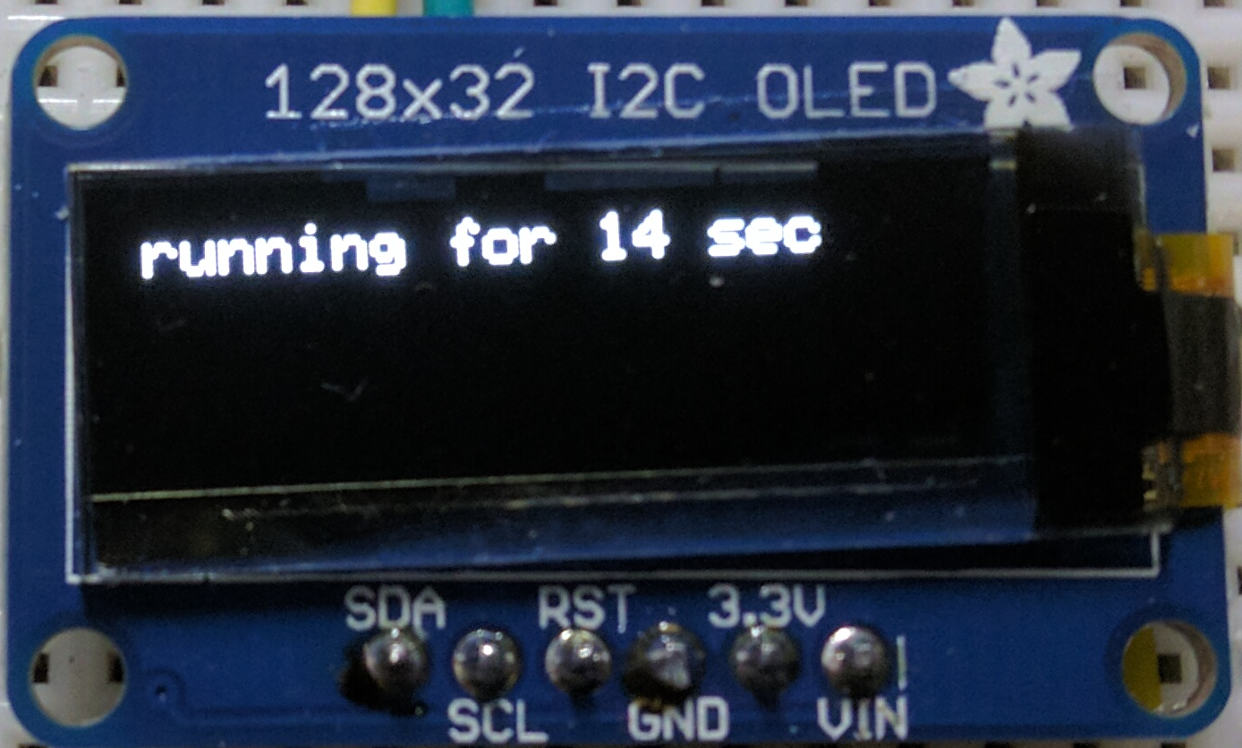
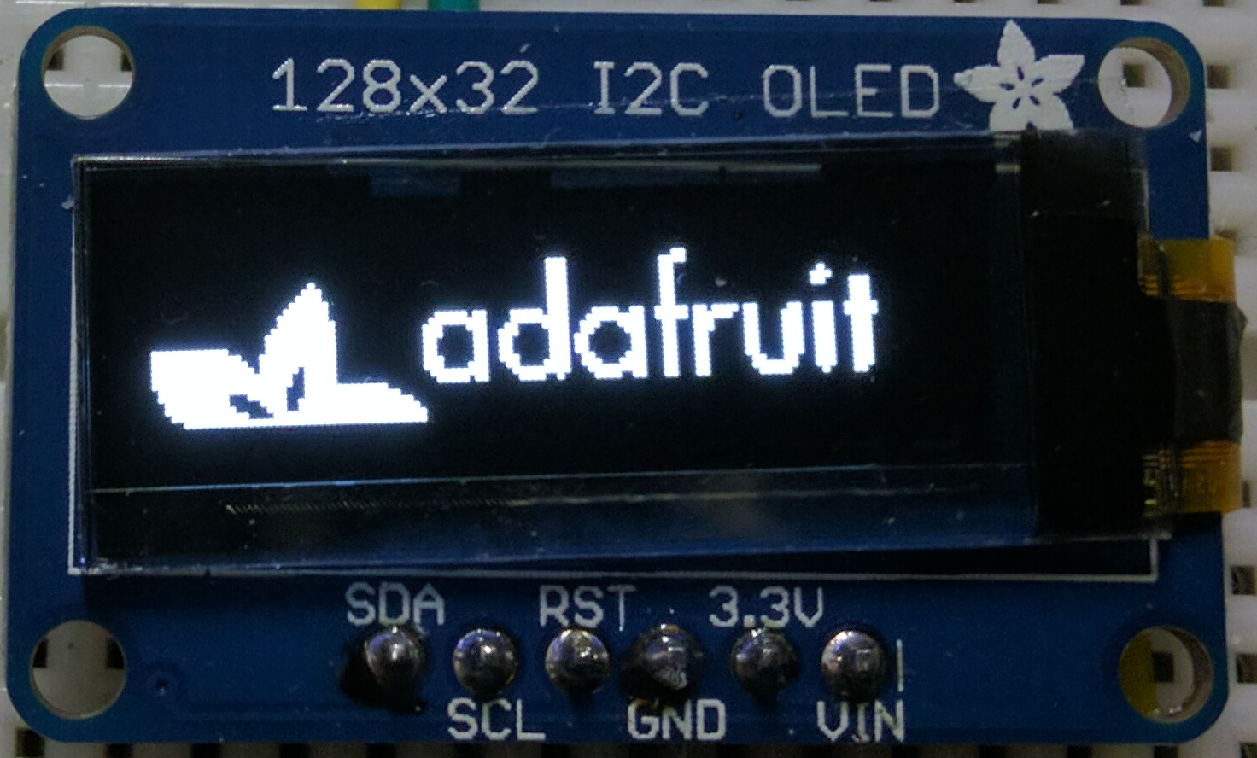

Code Walkthrough
#include <Wire.h>
#include <Adafruit_SSD1306.h>

Here we are including libraries into the sketch. The first library we include is the low level I2C code library called ‘Wire.h’. The next library we include is the manufacturers library from the 9DOF, this tells the Arduino how to get data off the device.

Adafruit_SSD1306 oled(0);
int address = 0x3C;
Here we are creating a variable that holds the OLED code. It expects a variable that specifies which pin the reset line is attached to. We're not using the reset pin in this example, so we just pass it zero. Again, we assign an address for the device, and more on that in the lecture on I2C communication.

void setup() {
oled.begin(address);
oled.setTextColor(WHITE);
oled.display();
delay(1000);
}

Here we start by initializing the display and specifying the address. We next specify that they text will be white against a black background as opposed to black against a white background. Finally, we call display to show the default splash screen. We leave this image up for 1 second.

void loop(){
int time = millis()/1000;
oled.setCursor(0,0);
oled.clearDisplay();
oled.print("running for ");
oled.print(time);
oled.println(" sec");
oled.display();
delay(1000);
}
First we create a variable that represents how long the program has been running in seconds. The millis() function gives us how long the program has been running in milliseconds, so we just divide by 1000. Next, we set the cursor to (0,0) to start writing text at the upper left hand corner of the screen. We call clearDisplay() to make sure no data from a previous command remains displayed. We call a series of print statements to print some text to the screen. Finally, we call display to update the display. We leave this up for 1 second before we do it all again.

